FEDERAL STATE AUTONOMOUS EDUCATIONAL INSITUTION FOR HIGHER PROFESSIONAL EDUCATION NATIONAL RESEARCH UNIVERSITY

«HIGHER SCHOOL OF ECONOMICS»

###### Faculty of Computer Science

Repina Anastasia Andreevna

Name, Surname

МОБИЛЬНОЕ ПРИЛОЖЕНИЕ ДЛЯ НАВИГАЦИИ С ИСПОЛЬЗОВАНИЕМ ДОПОЛНЕННОЙ РЕАЛЬНОСТИ

**Russian title**

MOBILE APPLICATION FOR AR NAVIGATION

**English title**

**Group:** MSE2018

Qualification paper – Master of Science Dissertation

Field of study 09.04.04 «Software engineering»

Program: System and Software Engineering

|  |  |
| --- | --- |
|  | Supervisor  Ph.D., associate professor of Software Engineering department of FCS  Akhmetsafina R.Z. |

Moscow, 2019

Abstract

Every day people navigate from one place to another in order to achieve their tasks and goals. One of the most common types of navigation is on foot. Walking through the streets people do not have to pay for tickets and stack into the traffic jams. According to the Boston Consulting Group and Ipsos research [[1]] people spend half of their life on going somewhere. So, inclusion of an educational or the cultural part to this way can broaden the people’s horizons and help not to get bored while walking. Although, it is the 21 century already, most of the citizens prefer to use paper maps or their online analogs in order to find the exact way. However, this case involves a lot of problems: from dependency on the stable internet connection up to the difficulties connected with understanding is it the right place to turn left of right. The existing applications on the market are devoted mainly to the usual maps and do not pay much attention to the improvement of the navigational process, which can positively influence of the user’s experience. So, that is why trying to make the everyday navigation easier seems a good idea. The only questions is how to do it?

The main purpose of the work is to create a mobile application which helps the user to faster and easier navigate to the destination point as well as stay informed of the nearby excursion places. The augmented reality is one of the options of how this goal can be achieved. Having an augmented reality projection together with a usual map can help to solve the mentioned difficulties, so the user’s experience will become even better. Monitoring the geolocation in a real time using the in-device modules and creation an augmented reality projection together with changes on the common map do not require the expenditure of personal time. In case of any problems the application will signal the user. It stores information about the excursion objects: theaters and museums, so while navigating to the destination location it is possible to learn more about the city where you are now. Furthermore, an opportunity to load the saved and frequently used routes can save time used for searching. The application is implemented using technologies: ARKit, Google Firebase, MKMap and others.

The proposed project is of great importance since it contributes to the improvement of contemporary complex and far from ideal approaches to human navigation. The application is available for download for more all the iOS devices which have the AR module inside on GitHub via the link - <https://github.com/arepina/AR>.

***Index Terms*** *— mobile application, iOS, geolocation, navigation, augmented reality, map.*

Definitions and acronyms

API – a set of tools for building software applications;

ARKit – a set of tools for the iOS platform which are used the augmented reality creation;

Augmented reality (AR) – the result of blending of interactive digital elements together with the real world;

CoreLocation – framework which is used for access the geolocation data of the device;

Firebase – is a mobile and web application development platform developed by Google;

Geolocation – the position coordinates of the object on the Earth;

GitHub – the largest web service for hosting IT-projects and their joint development;

iOS – mobile operating platform;

MapKit – framework which is used for setting a map to the application;

SDK – software development kit;

Splash-screen – an introduction screen inside the application;

Swift – programming language which is used for the iOS applications development;

UI – user interface;

Virtual reality (VR) – is an interactive computer-generated experience taking place within a simulated environment;

Walkthrough-screen – a several page screen used for helping with understanding of curtain tasks;

Widget – an additional part to the application which is used to perform the main operations faster;

XCode – and iOS development tool;

ZenHub – independent project management tool natively integrated with GitHub.

Contents

Abstract 2

Definitions and acronyms 3

Introduction 6

1. Existing solutions 8

1.1. Applications for AR navigation market 8

1.2. Existing solutions overview 9

Conclusion 14

2. Requirements 15

2.1. Functional requirements 15

2.2. Interface requirements 15

2.3. Input and output format requirements 17

2.4. Reliability and security requirements 17

2.5. Terms of Use 17

2.6. Requirements for the composition and parameters of technical equipment 17

2.7. Requirements for information and software compatibility 17

2.8. Marking and Packaging Requirements 18

2.9. Requirements for transportation and storage 18

2.10. Special requirements 18

Conclusion 18

3. Information model and algorithms 19

3.1. Information model 19

3.2. Navigation formulas 19

3.3. Steps algorithm 23

3.4. AR objects algorithm 25

3.5. Widget algorithm 27

Conclusion 28

4. Architecture and design 29

4.1. Architecture description 29

4.2. Design and interface 30

4.2.1. Application 30

4.2.2. Widget 31

Conclusion 32

5. Technology stack and implementation details 33

5.1. Development tools 33

5.2. Main libraries 33

5.2.1. ARCL library 33

5.2.2. SideMenu library 33

5.2.3. SwiftSpinner library 34

5.2.4. SwiftLocation library 34

5.3. Main third party services 34

5.3.1. ARKit 34

5.3.2. MapKit 35

5.3.3. CoreLocation 35

5.3.4. Firebase 36

5.3.1. Crashlytics 36

5.3.2. GitHub 37

Conclusion 37

6. Conclusion 38

7. References 40

Introduction

Over the past few years, the mobile applications market has seen a significant increase in the number of new programs that solve various tasks [[2]]. Now the most familiar things can be done online using a phone or tablet: ordering the food, playing games or just talking with friends and relatives, without wasting time moving from one place to another. This success can be explained by the emergence of new special tools and devices that can be associated with the mobile phones, as well as with the emergence of new features within the gadgets themselves.

Everyday people solve navigation problems trying to find the shortest and fastest way from one place to another. Although, this problems has other aspects, which people do not spot from the first glance. During the way there are a lot of direction changes, so each time user has to check whether is it the right place to turn somewhere, for example. So, the lack of an ordinary map functions as well as the difficulties of the unknown route navigation are also important points of the navigational task. Furthermore, the problem becomes even more complicated when the navigation type is restricted and we choose only “on foot” option. In that case pedestrians walk more freely in the available space, so it is necessary to adapt the route more often. Over the last decade researchers have become developing systems based on the current situation around the user, not the one which was at the start of the route [[3]]. That is why applications for the outdoor navigation for pedestrians is the separate part among the other navigational cases.

Previous studies show that augmented photos enhance map-based navigation systems [[4]]. Chittaro [[5]] shows that AR images help users in making correct decisions at road intersections faster than an ordinary map. Hile [[6]] highlights an 80 to 20 rule, where 80% of the time is being spent on the map and 20% (“at critical points in the path”) on augmented pictures. In contrast, AR anchors the collected information to the real-time video from a device’s camera. According to the Manifest research [[7]] over 77% of smartphone owners regularly use navigation applications. That means that the auditory is very huge and the solution of the problems inside this applications as well as new functionality can improve the user-experience and attract new clients. In the context of this work, the author will try to do both.

Augmented Reality is now being used by the world leader in GPS navigation technology, allowing a virtual overlay to live cameras in real-time. The majority of the new mobile phones and tablets support the AR function. That is why using the AR inside the pedestrian navigational application sounds as a good idea as the opportunities of the technology will help to solve the ‘wrong turn’ problem as well as help to better understand what is around the user.

**The goal of this work is** thecreation of the mobile iOS application for outdoor AR navigation for the pedestrians. The created application will be used for the route-finding purposes. Using this application user will be able to navigate to the destination point from the current location using both usual map and the AR mode. There are no specific restrictions of whom can use the application. However, the person should not have any visual or motor disabilities which can spoil the user experience. Also, it is necessary to have an iOS platform device with an AR module inside.

**In order to achieve the goal several tasks should be done:**

1. Study of the subject area, analysis of existing solutions;
2. Development of application functionality;
3. Selection of technical means of implementation and platform;
4. Development of models and algorithms for data transmission and processing;
5. Study of technical means of implementation and platform;
6. Choose of modules and application architectures;
7. Development of application design;
8. Application development and testing;
9. Development of technical documentation.

In the further chapters, the existing analogues of the AR navigation applications are analyzed, the platform is selected (Chapter 1), the requirements for the application are stated (Chapter 2), the information model, as well as the steps, objects, navigation and widget algorithms are established (Chapter 3), the architecture and the design of the application are explained (Chapter 4), the chosen libraries and the technology stack, as well as the details of the software implementation are mentioned (Chapter 5). In conclusion, the main results of the work are presented and the ways of its continuation are considered.

1. Existing solutions

In this chapter the AR market and existing analogues of applications for navigation are analyzed, the platform is selected.

* 1. Applications for AR navigation market

According to the DigiCapital “Augmented/Virtual Reality Report and Database Q1 2018” [[8]]report, AR could approach $3,5 billion installed base and $120 billion revenue within 5 years. At the same time, VR might deliver $50 million installed base and $30 billion revenue (pic. 1).

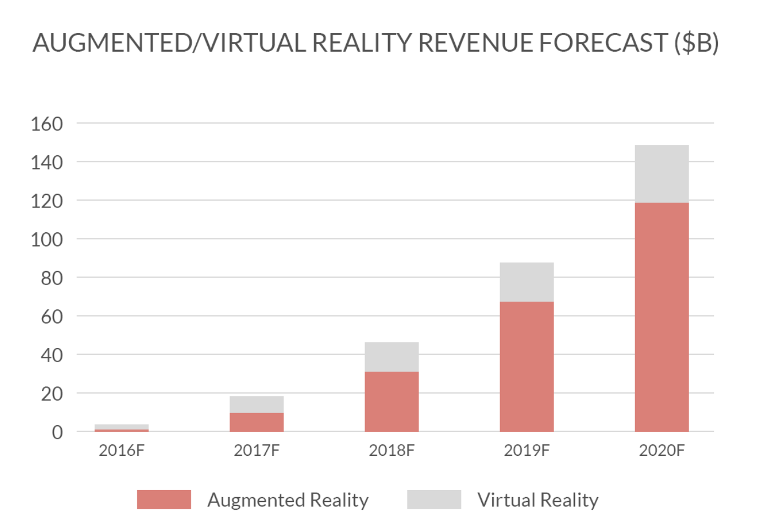

Picture 1. AR/VR Platform Revenue

That is a pretty big difference, and it all has to do with AR’s ubiquity and VR’s focus. The main reason for that might be connected with the VR’s lower mobility and exclusive immersion focuses it on entertainment use cases and revenue streams whereas the AR applications try to cover all the market. Furthermore, the navigation AR applications category is the 4th largest among all the possible markets (pic. 2).

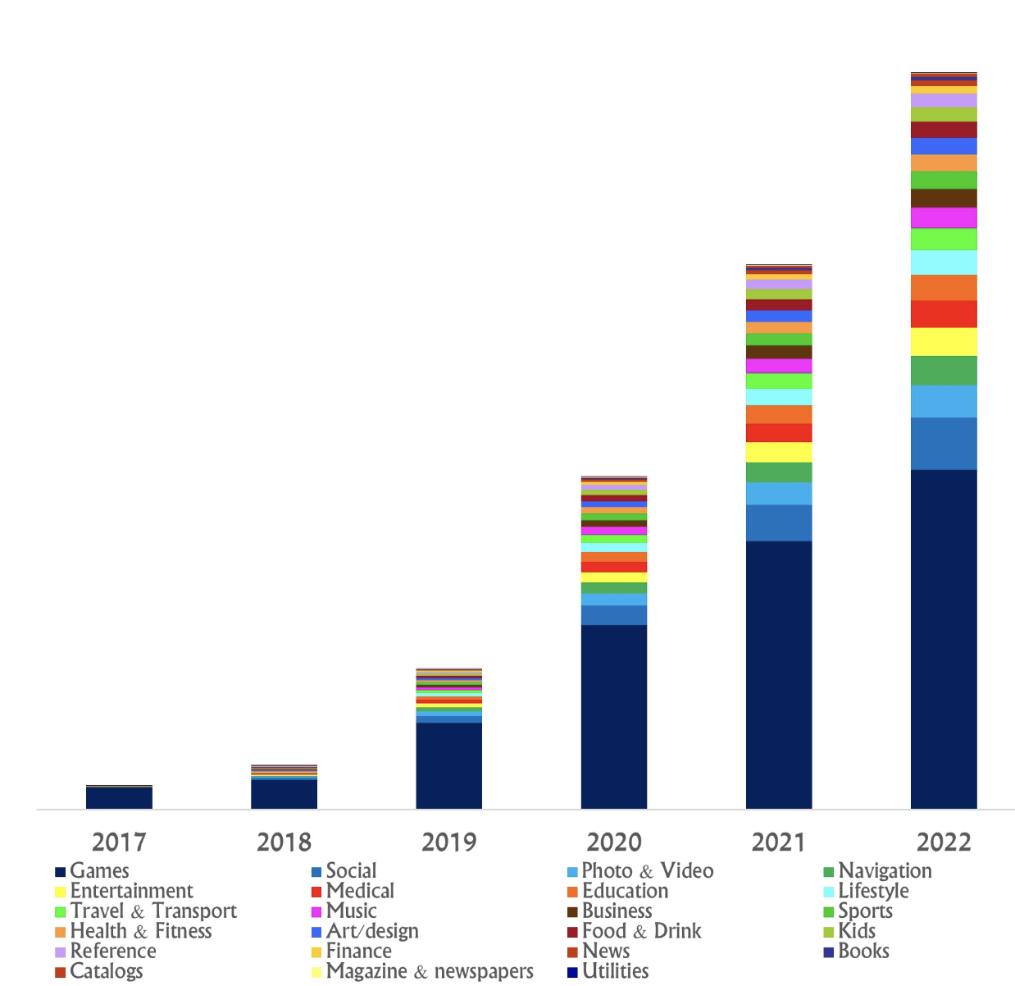

Picture 2. AR categories popularity

It inferiors in popularity to the utilities, art and social categories only. Although, the revenue numbers in the navigation AR applications category are the highest (pic. 3). So, the opportunities of the development the application for the navigation using augmented reality are huge enough.

As indicated by another report from Tractica [[9]], the expanding use cases for mobile AR will lead to growth from 342.8 million unique monthly active users (MAUs) globally in 2016 to nearly 1.9 billion MAUs by 2022.

Obviously, the AR is a bit rough yet and still in its early stages. Nevertheless, taking the above numbers into consideration, it is possible to predict the AR’s quick advancement and development on account of some key drivers as an expanding number of telephones and tablets and their all-encompassing usefulness or the expanding Internet speed.

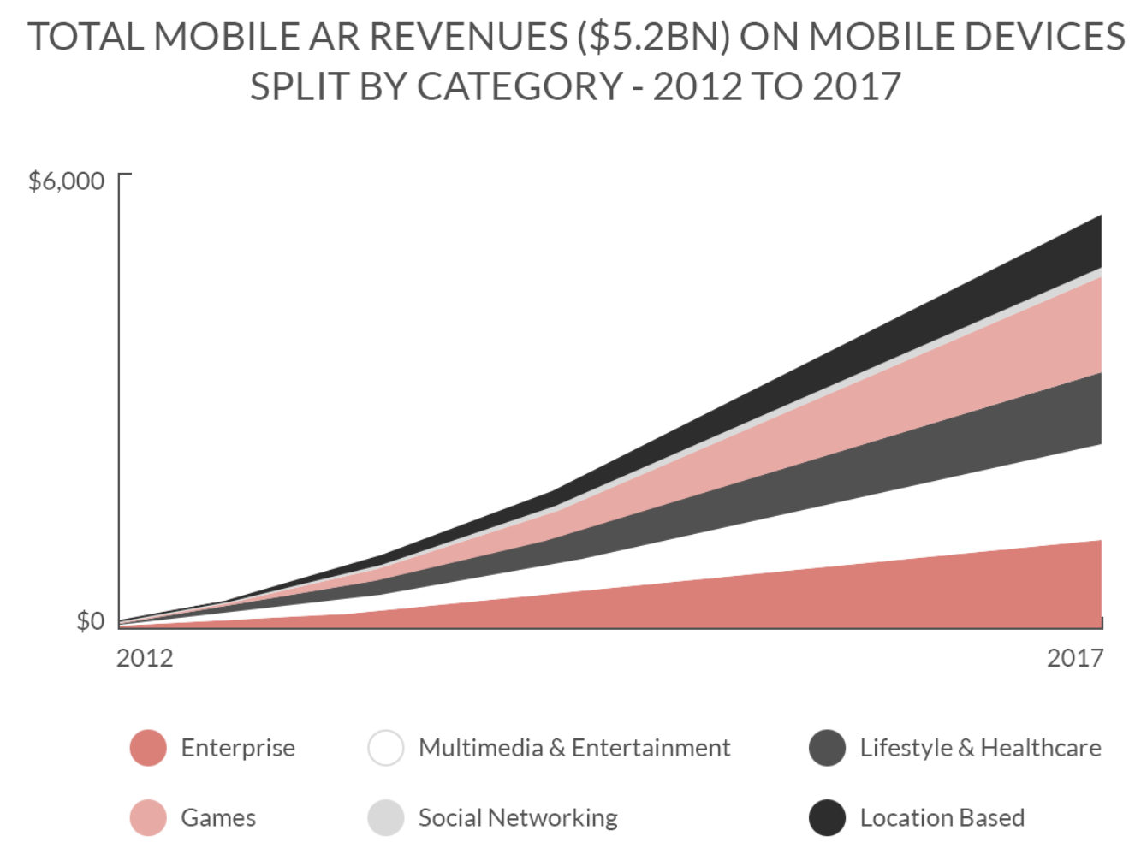

Picture 3. AR revenues split by categories

The augmented reality system and the virtual reality system have one fundamental difference [[10]]; that is, virtual reality attempts to replace the real world, while augmented reality adds information to reality, as shown in picture 4 [[11]].



Picture 4. Reality-virtuality continuum

* 1. Existing solutions overview

As part of the research work, the preparatory stage is very important. At this stage, it is necessary to analyze existing projects and understand what their benefits and drawbacks are. Thus, it will later be possible to create your own work, taking into account the problems and advantages of the competitors.

The corresponding review within the framework of the work was carried out not only for the IOS platform, but also for the Android one with the aim of a more extensive study of the area. In each application, five parameters were evaluated: price, AR mode existence, stability of work, availability of a favorite places mode and search module (Table 1).

Table 1

Analogues table

|  | **Price** | **AR mode** | **Map mode** | **Stability** | **Favorite places** | **Search** |
| --- | --- | --- | --- | --- | --- | --- |
| Yandex Maps | free | + | + | +/- | + | + |
| Google Maps | free | + | + | + | +/- | + |
| Apple Maps | free | - | + | + | + | + |
| Welc map | free | +/- | + | - | - | - |
| Eye maps | $4.99 | - | - | + | - | + |
| Wikitude | free | +/- | - | + | + | +/- |
| AR Maps | free | +/- | + | - | + | + |
| Mosgorpass | free | + | + | +/- | + | + |
| ARCity | free | + | + | +/- | - | + |
| My application | free | + | + | + | + | + |

“Yandex Maps” [[12]] – search and information map service by Yandex created for both iOS and Android operating platforms, which helps to find all the necessary addresses, streets, get directions and make plans for the trips and travels. The application also provides functionality to store favorite places in the city. The beta version of the application with the AR mode is not stable yet as it is possible to catch an exception during the usage (pic. 5).

“Google Maps” [[13]] – a set of applications built on the basis of a paid map service and technology provided by Google. The application has a well-working AR mode which can be easily combined with the usual map. So, the user can choose which mode to use or use both. However, the search mode does not provide enough functionality to work with favorite places, so this is one of the points to the future improvements of the applications (pic. 6).

|  |  |
| --- | --- |
| https://www.iphones.ru/wp-content/uploads/2017/09/ar_ya6.jpg | https://heise.cloudimg.io/bound/1920x1920/q90.png-lossy-90.webp-lossy-90.foil1/_www-heise-de_/imgs/18/2/4/2/3/0/5/8/2018-05-08__199_-d575b373258a39c5.png |
| Picture 5. IOS application “Yandex Maps” | Picture 6. IOS application “Google Maps” |

“Apple Maps” [[14]] – Apple's mapping service for iOS and MacOS operating systems, the intellectual functions of which will help to easily find the right place and quickly get to it. The application is built into the both mobile and desktop versions. However, it does not have an AR mode yet, although the ARKit framework is highly popular and is promoted by the Apple company (pic. 7).

“Welc map” [[15]] – is an Android and iOS application created by SPAM company, which provides information about the excursion places nearby using the AR mode. However, every function inside the application have problems with stability and regularly throw exceptions. Also, the search engine helps to find only the places which were added by the developers to the list, although it might be necessary to look for other places nearby. Furthermore, it is impossible to save the favorite AR places to visit them later, for example (pic. 8).

|  |  |
| --- | --- |
| https://www.tabletowo.pl/wp-content/uploads/2018/07/nowe-Mapy-iOS-Apple-1115x900.jpg | http://augmentyourjourney.altervista.org/wp-content/uploads/2018/01/11-1.jpg |
| Picture 7. IOS application “Apple Maps” | Picture 8. IOS application “Welc map” |

“Eye maps” [[16]] – an iOS and Android application created by Kostas Gaitanis, which provides a 3D map of the world displaying instantly what you see. It is possible to look for the any place of the Earth and see what is located nearby, but not in the AR. Also, the application is not free to use and requires 4,99$ payment for an access (pic. 9).

“Wikitude” [[17]] – an all platforms application created by Wikitude GmbH which has a broad range of functions for excursions. The AR mode was added in one of the latest releases, however it is not working properly yet. Furthermore, the search engine has some logic mistakes in the code, so it can show the wrong places (pic. 10).

|  |  |
| --- | --- |
|  | https://www.poderpda.com/wp-content/uploads/2012/05/wikitude-android-e1337655320576.jpg |
| Picture 9. IOS application “Eye maps” | Picture 10. IOS application “Wikitude” |

“AR Map” [[18]] – an iOS application created by Chirag Leuva. It provides functionality to navigate from one place to another using the map or AR mode. Also, it has functionality of favorite places and a good search solution. However, the stability of the work is the main problem of the application (pic. 11).

“Mosgorpass” [[19]] – an iOS application create by the Mosgortrans. It allows real-time monitoring of the movement of ground-based urban passenger transport in Moscow and provides up-to-date information on schedules, arrival time of the desired bus, tram or trolleybus to a stop and estimated time of arrival at its destination using the AR mode. However, the stability of the applications is the same problem as in the previous application (pic. 12).

|  |  |
| --- | --- |
|  |  |
| Picture 11. IOS application “AR Map” | Picture 12. IOS application “Mosgorpass” |

“ARCity” [[20]] – an iOS application created by Blippar. It provides one of the best AR mode from the examined applications. Although, it is possible to search for any place in the city, the user can not add them to the favorite places list (pic. 13).

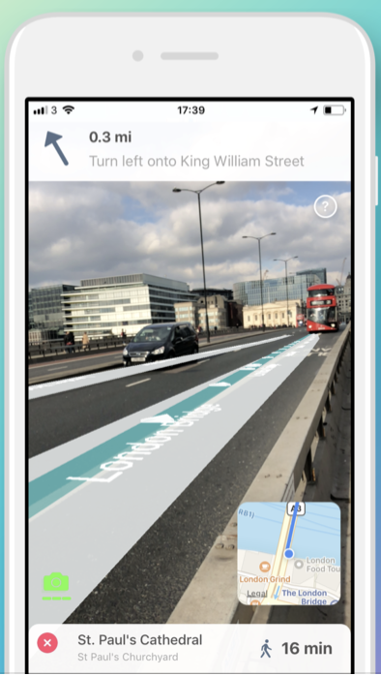

Picture 13. IOS application “ARCity”

As can be seen from the table. 1, the mobile application that will be created as a result of this work will have an advantage over the main competitors, since they have limited functionality and problems with work stability and the AR mode. Economic and financial issues are not considered in the work. The application will be distributed free of charge. None of the studied applications solves all problems, which indicates that the problem exists, and it can be solved by combining the successful ideas and approaches in a single project.

The developed mobile application will be created for the IOS operating system. According to IDC Quarterly Mobile Phone Tracker [[21]], companies sold a total of 344.3 million smartphones worldwide in the first quarter of 2017 (1Q17). The share of iOS in the smartphone market continues to occupy about 32% of the global volume. Furthermore, the iOS platform has an ARKit framework which let the developers easily create the applications with the augmented reality. That is why this platform was chosen for the application.

Conclusion

The chapter reviewed and analyzed the existing applications in the market. Development platform was selected.

1. Requirements

The chapter describes the requirements for the application.

* 1. Functional requirements

The application should provide functionality to perform the following tasks:

1. Create an account from the sign in screen
2. Log into the existing account from the sign in screen
3. Log out of the account from the settings screen
4. Find the destination place using the search line from the main screen
5. Set the destination point by the map tap from the main screen
6. Set the destination point by the search line from the main screen
7. Navigate to the destination point using the map from the main screen
8. Navigate to the destination point using the AR mode from the main screen
9. Combine the map and AR modes for navigation from the main screen
10. Add and remove the current location and the destination place to the “favorite places” list from the main screen
11. Load the location from the “favorite list” and set it as the destination point from the “favorite places” screen
12. See the number of meters and the time up to the finish point from the main screen
13. Send a request to the AR mode, location and the camera of the phone from the main screen
14. Send an email to the developer from the settings screen
15. See the application information from the information screen
16. See the walkthrough of all the necessary request changes from the settings screen
17. Load the theaters objects from the main screen
18. Load the museums objects from the main screen
19. Move the map to the current location by button tap from the main screen
20. Close the current route from the main screen
    1. Interface requirements

Below screen layouts are presented that are planned to be changed during the development process (pic. 14-18). The layouts were created using the Figma service [[22]].

|  |  |
| --- | --- |
|  |  |
| Picture 14. Sign In/Sign up screen | Picture 15. Main screen |
|  |  |
| Picture 16. Navigation screen | Picture 17. Settings screen |

|  |
| --- |
|  |
| Picture 18. Route screen |

* 1. Input and output format requirements

Input data - user clicks on the screen.

Output - change the image on the screen.

* 1. Reliability and security requirements

Usage of the mobile application should not lead to the unhandled exceptions and shutting down of the application with an error.

* 1. Terms of Use

The end user of the program (operator) must have practical skills in working with the graphical user interface of the iOS operating system.

* 1. Requirements for the composition and parameters of technical equipment

1. Device based on iOS version 11 and above with the AR support;
2. Availability of internet connection;
3. Availability of geolocation;
4. Availability of camera.
   1. Requirements for information and software compatibility

Software:

1. iOS version 11 and higher;

2. Camera with the AR support;

Allowed to use in the development of the following software:

1. Firebase API;
2. Crashlytics API;
3. ARCL library;
4. SideMenu library;
5. SwiftSpinner library;
6. SwiftLocation library.
   1. Marking and Packaging Requirements

It is possible to download and install the application from the GitHub by a user who has the required hardware.

* 1. Requirements for transportation and storage

Requirements for transportation and storage of the application are not presented.

* 1. Special requirements

There are no special requirements for the application.

Conclusion

The chapter presented the requirements for the application.

1. Information model and algorithms

The chapter describes the developed information model, steps, objects, navigation and widget algorithms.

* 1. Information model

To store the accumulated information the database creation was selected. It was decided to use a relational No-SQL database. A data model was developed in the third normal form, in which many-to-many links are not used. The database consists of 11 tables, described in Table. 2

Table 2

Database

| **Table name** | **Fields** | **Description** |
| --- | --- | --- |
| Routes | string : key  string : coordinates  string : place | Saved routes |
| Users | String : key  String : email  String : create_time  String : update_time | Users |

All the table links are presented on the pic. 19

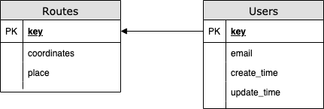

Picture 19. Table links

For each table in the application, there is an analogue that is associated with the storage using the Firebase API, which will be further described in Chapter 5. Keys that link data in the tables are generated by the Firebase service automatically and during the creation of a new record in one of the tables, the correct key is placed.

* 1. Navigation formulas

The geolocation module of the phone is the main source of data inside the application. So, the navigation algorithm uses exactly the coordinates which are tracked by this module with no intermediary layers. There are two types of coordinates. Geodetic one is the position of the objects (route points) in the real world. There are two parameters of the geodetic coordinate: latitude and longitude. Latitude is the distance between the North or the South Pole and the equator, whereas longitude is the distance from the prime meridian (an imaginary line running from north to south through Greenwich, England) to a point at the west or east. Another coordinate type is the cartesian. This type is the position of the objects on the scene (in ARKit). Translation from one coordinate system to another and vice versa is possible due to the fact that coordinates in ARKit are measured in meters, and the offset between two geodetic coordinates can be translated with great precision into offset in meters along the X and Z axes of the ARKit coordinate system at small offsets.

In order to make the coordinates usage possible it is necessary to let the application connect to the geolocation module. The request will be made during the first entrance to the application (pic. 20).

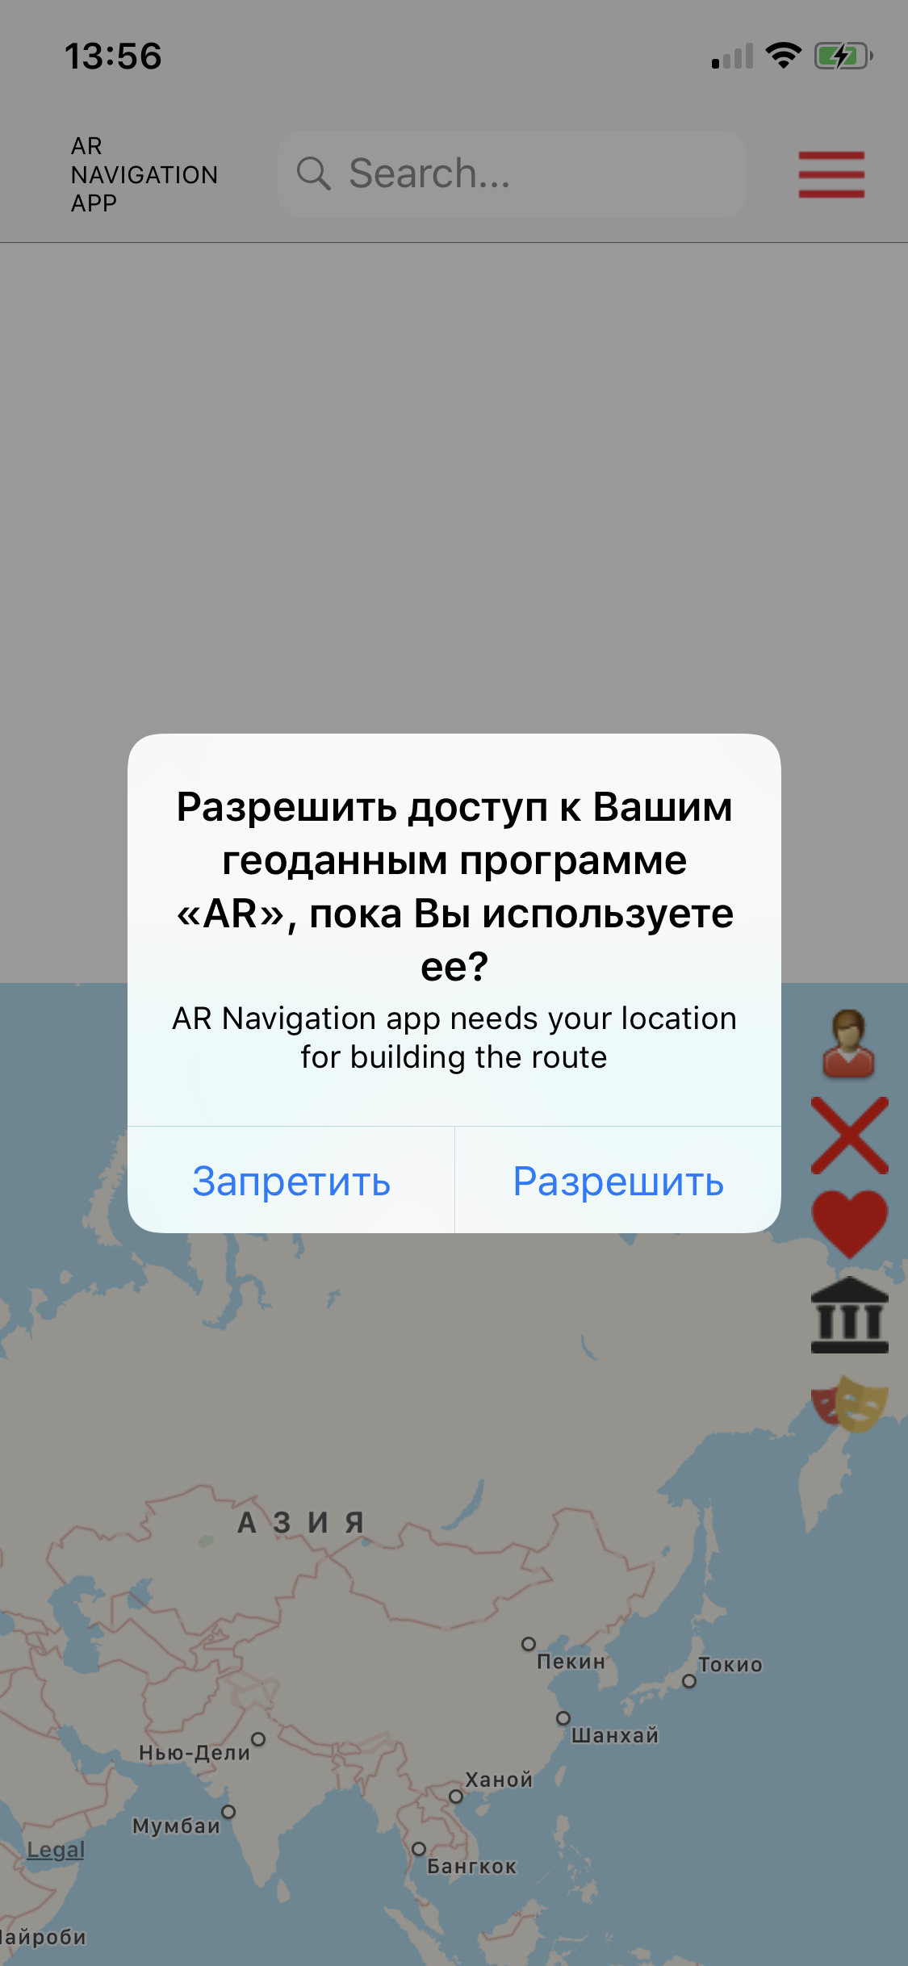

Picture 20. Geolocation access request

The same situation applies to the ARKit. It also needs a permission to use the camera of the phone (pic. 21).

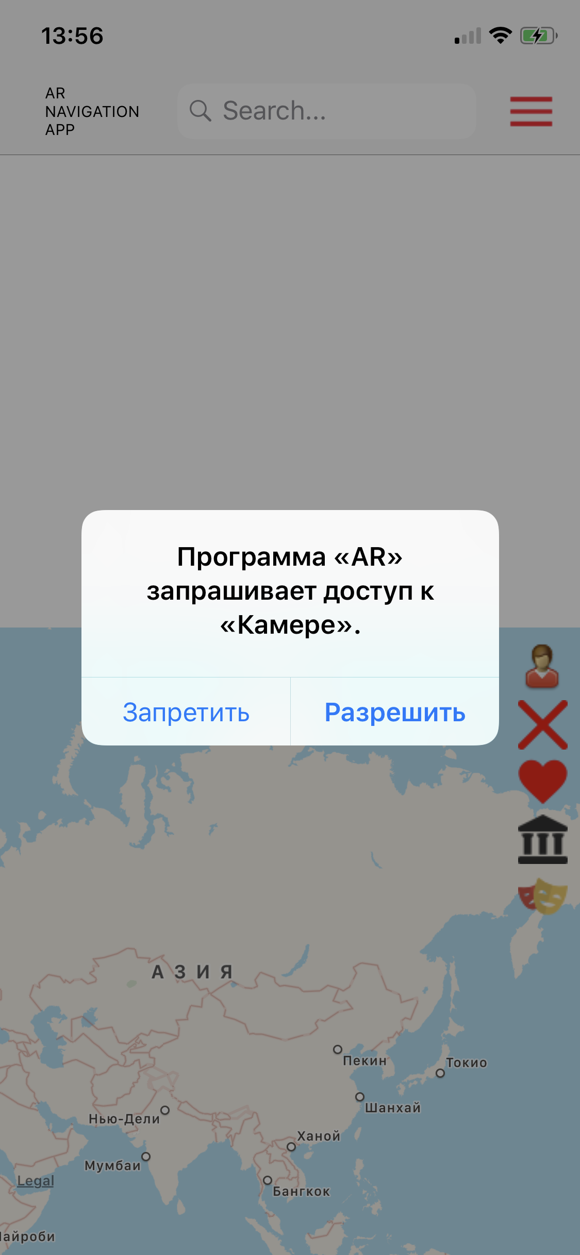

Picture 21. Camera access request

After all the permissions are granted is it possible to use all the functions of the application. In order to track the current users location the listener is created. Each second it updates the coordinates via a special request directly to the geolocation module. The main application algorithm is divided into several steps (pic. 22) [[23]]. Each of them is responsible for their own mathematical calculations. The mentioned methods in the next sections are used for the making the navigation algorithm work properly.

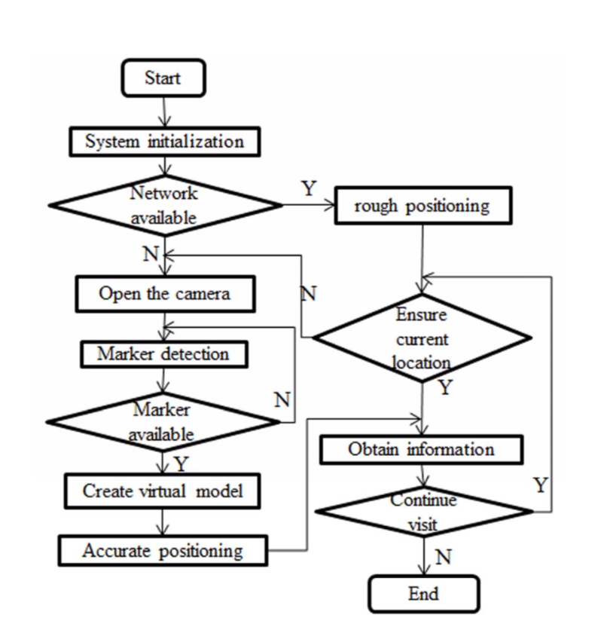

Picture 22. Main parts of the navigation system

During the development process several technologies were used. First of all, it is the ARKit itself. None of the augmented reality applications for the iOS can be done without this framework. For the navigational purpose CoreLocation framework was chosen as the most frequently used one. Together with the iOS 11 release the Apple company has unleashed the power of ARKit onto the iOS development community. The ARKit is SDK for working with augmented reality. The undoubted advantage of ARKit is its native nature as integration and configuration takes only a few minutes. Xcode kindly does half the necessary operations for you, after which the framework "just works." It is very easy to organize the interaction between ARKit and other system frameworks like CoreLocation. CoreLocation provides services for determining a device’s geographic location, altitude, orientation. The framework uses all the available onboard hardware, including Wi-Fi, GPS, Bluetooth, magnetometer, barometer, and cellular hardware to gather data. That is the combination of this two framework is used inside the developing application.

Earth is not a flat plane, so the math gets more complex (pic. 23).

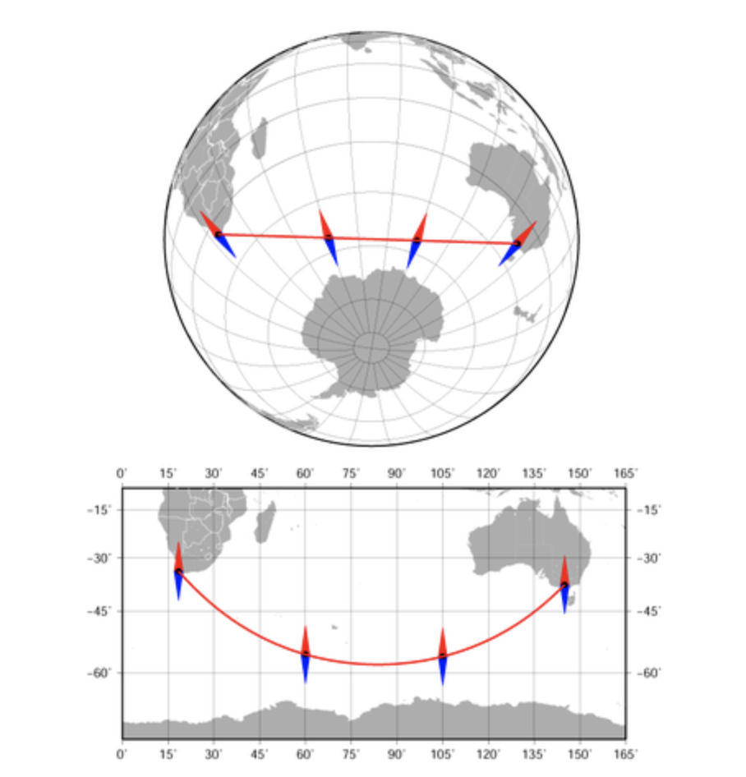

Picture 23. Example of the shortest distance between two points of the Earth

In order to calculate the distance between two points on the Earth it is necessary to use the special formulas. Having two different coordinate values of two different point on earth with the help of Haversine Formula, it is compute the great-circle distance - the shortest distance between two points on the surface of a Sphere (sch. 1) [[24]]. One of the main drawbacks of this formula is that we get less accurate results on the big distances, so it should not be used in aviation, for example. However, the current problem is not about the big distances, so we can use the haversine formula for our case.

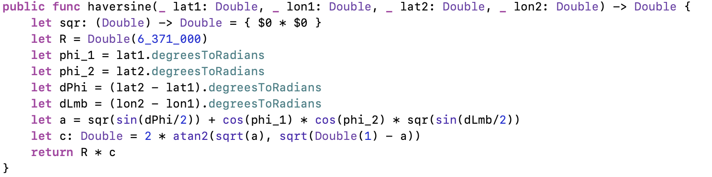

Schema 1. Haversine formula method

Now it is necessary to explain how to calculate the bearing - the angle between two coordinates. The final heading will be different from the current one by varying degrees according to great circle distance and latitude. For example, if we start from Baghdad 35°N,45°E and navigate to Osaka 35°N,135°E, then having the current heading of 60°, the final point ends up on the heading of 120° (pic. 24).

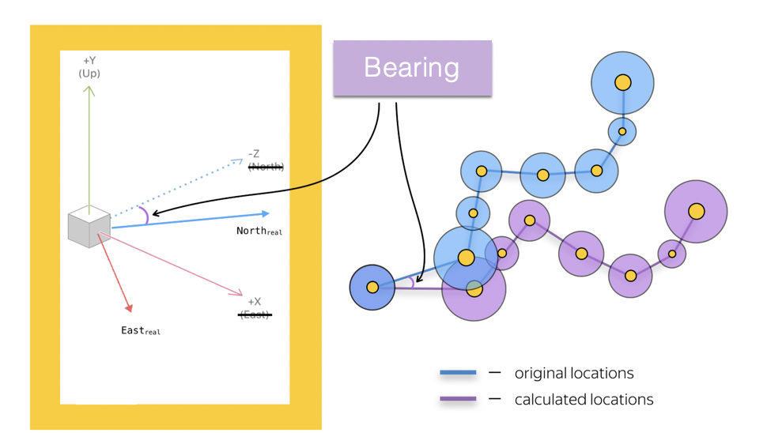

Picture 24. Example of how the bearing changes the direction of the nodes

So, the bearing formula helps to properly orient the node in the environment, thus the direction and the final heading will be correct (sch. 2).

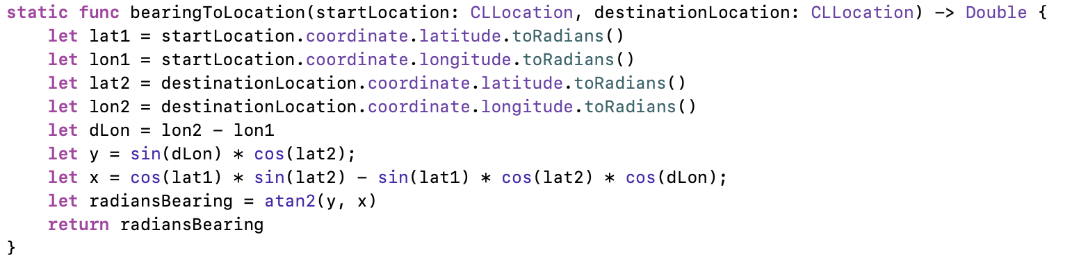

Schema 2. Bearing formula

* 1. Steps algorithm

The MKRoute framework is applied for building an ARKit navigation experience. However, the main points among the path gained with the help of the framework can be too far enough from each other, so the future AR experience may be ruined. To solve that problem it is possible to iterate through all the main steps and calculate the intermediary coordinates for each of the legs between them. So, that is why there are two types of steps: main (red) and intermediary (blue) (pic. 25).

In order to calculate each of two coordinate types it is necessary to perform several actions. The main steps of the route are those in which, for example, the direction can be changed, the user turns left or right. After we calculated the main points of the route it is necessary to link them into a route. For that reason the intermediary steps are calculated. The calculation of the main points is given to the integral maps API, created by the iOS developers. In order to find these steps the developer needs to pass the start and finish coordinates as well as the type of transport which is supposed to be used. In our case, this type is named “walking”. Although, it is possible to see the main routes for a “car” type route.

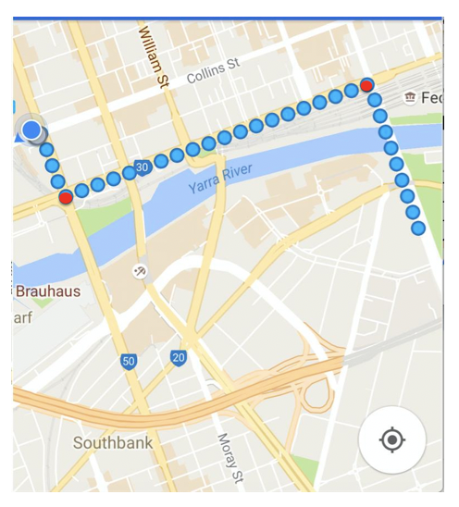

Picture 25. Steps types example

In order to calculate the main steps of the route we do the following (sch. 3):

* Get the start and final points of the route
* Set the transport type as “walking”
* Form an MKDirections request
* Add the results of the request to the steps array

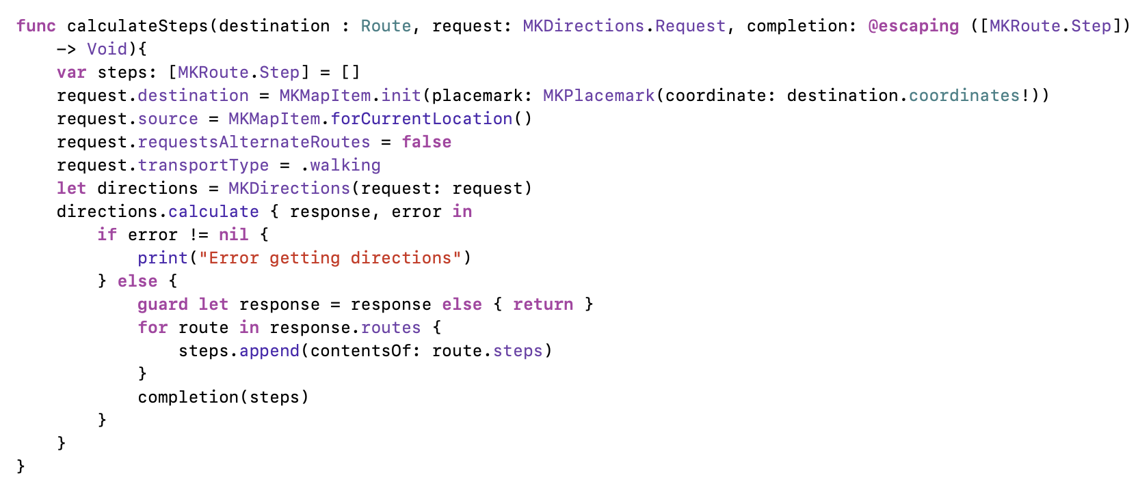

Schema 3. Main steps algorithm

After the main steps are found it is necessary to convert them into the AR suitable coordinates system. That transformation is performed using the convert method (sch. 4).

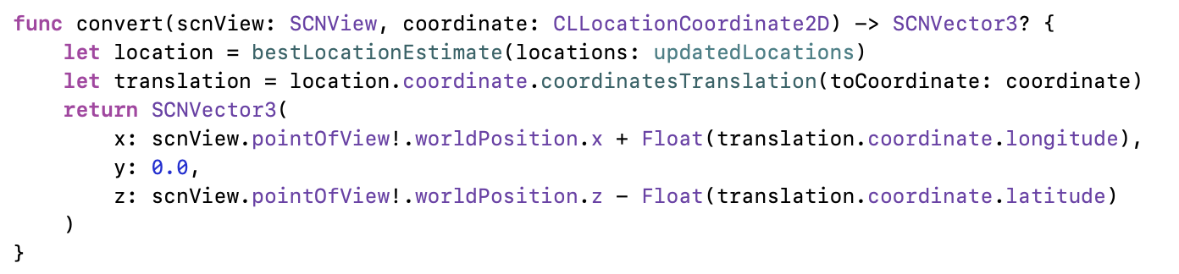

Schema 4. Conversion of the coordinates to the AR suitable

Now, move on to the intermediary steps, which are found without additional frameworks and libraries. We know a start coordinate, bearing gained with the help of the bearing formula, and the distance gained with the haversine formula, so it is possible to calculate the points of the way to the destination location (pic. 26).

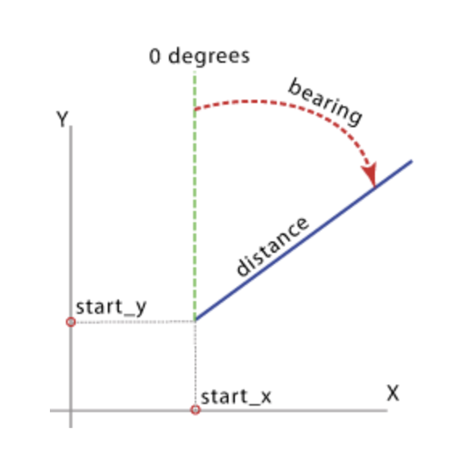

Picture 26. The destination point calculation

All the main steps of the route are passed to the getLegs method, inside which all the route legs are found (sch. 4).

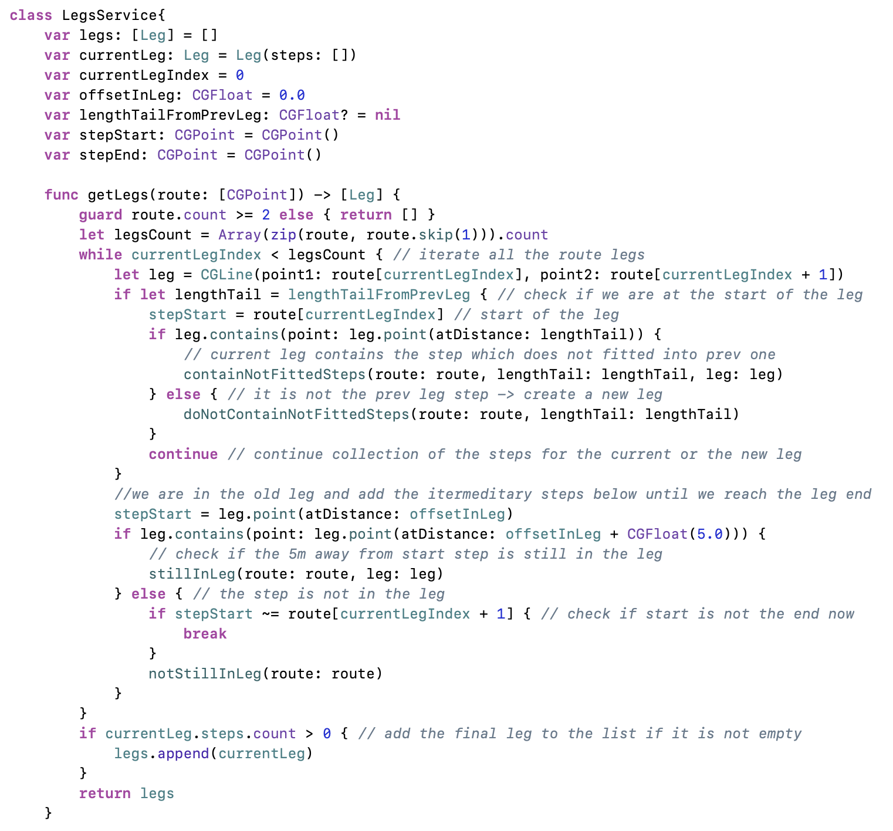

Schema 4. Route legs calculation

* 1. AR objects algorithm

After we have found all the necessary steps of the route, both main and intermediary, and combined them into one array, it is possible the perform the AR navigation creation. Although, the array of the route steps is also passed to the common map creation. We pass the values to the setNavigation method, inside which the AR nodes are created (sch. 5).

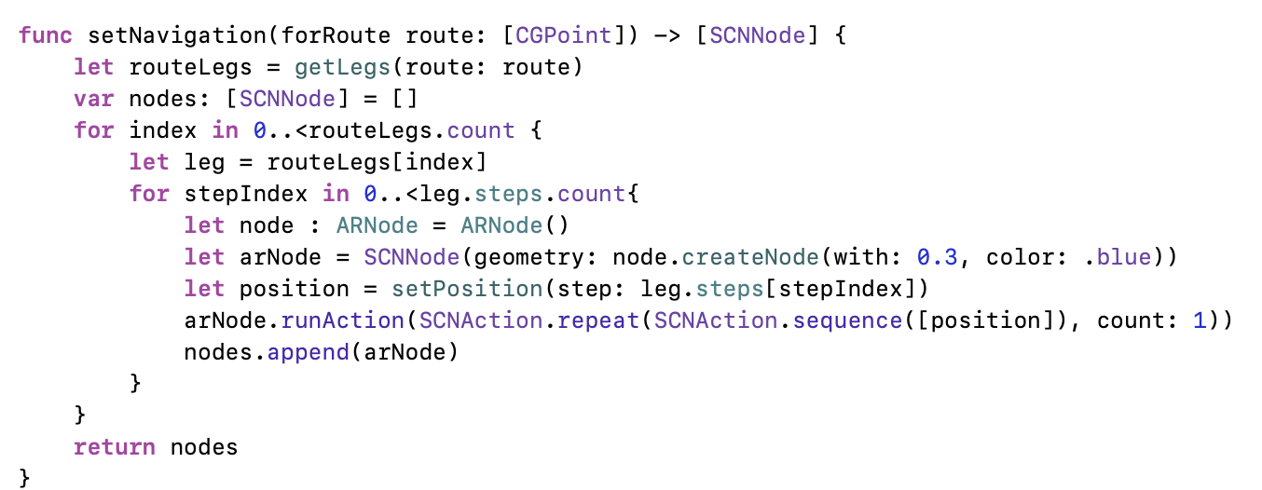

Schema 5. AR nodes creation

In order to perform the navigation in augmented reality it is necessary to create AR objects for each of the calculated nodes. So, it is also important to mention, how the AR node is created itself. For the visualization purposes the bean form was chosen for each of the nodes. Also, we need to position the nodes in the augmented reality. For that purpose, we call the setPosition method, inside which the AR position is set as well as some extra parameters needed to the better user experience (sch. 6).

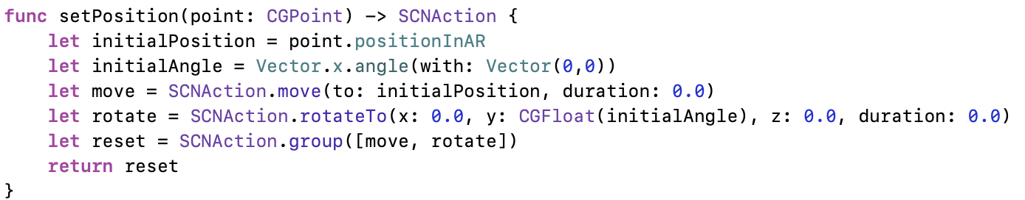

Schema 6. AR node position

There are three types of the AR nodes in the application:

* The first is used for showing the steps of the routes (sch. 7)
* The second is used for showing the text above the main steps of the routes (sch. 8)
* The third is used for showing the images of the excursion objects (sch. 9)

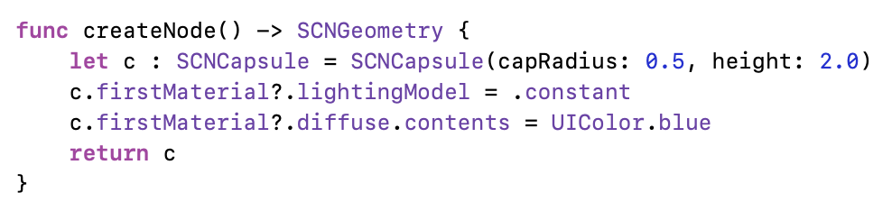

Schema 7. Steps node

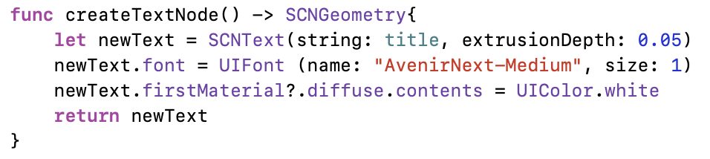

Schema 8. Text node

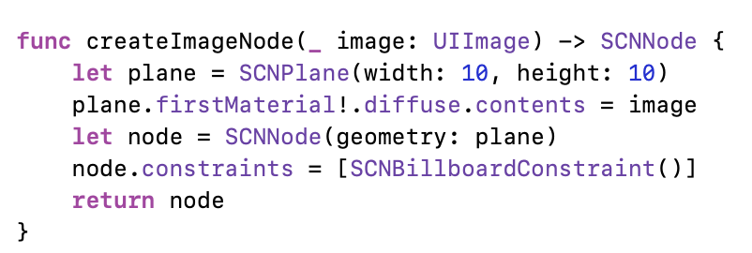

Schema 9. Image node

In order to create the AR node one the methods above are called. For example, in order to get the steps node it is necessary to write: *let arNode = SCNNode(geometry: node.createNode())*. Furthermore, in order to put the information for each direction change above the AR node, the AR labels with text are used. For that reason the String class extension was created, which converts the text into the augmented reality image, which can be added to the specific node (sch. 10).

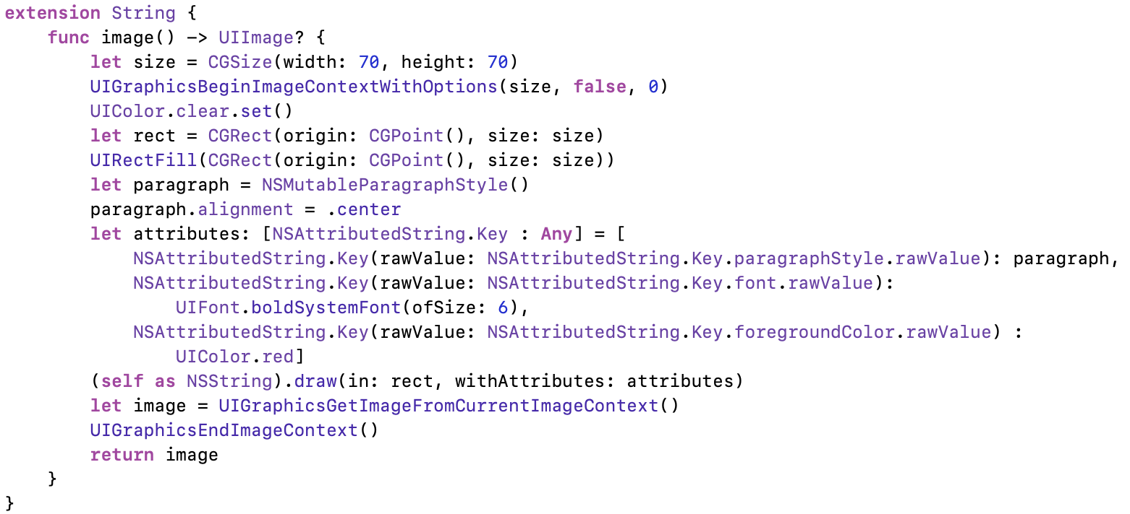

Schema 10. AR labels

In order to use the extension method it is necessary to write: *let textNode = node.makeBillboardNode(objects[index].title!.image()!)*.

There are two types of excursion objects which exist in the application: museums and theaters. The main source of the data is the data.gov.ru site - the official open resource for Russian Federation, where the official theaters and museums of Moscow are stored in the json files. The excursion objects are also added to the AR using the image and text nodes. The collected information from the json files is passed to the AR nodes creation method (pic. 27).

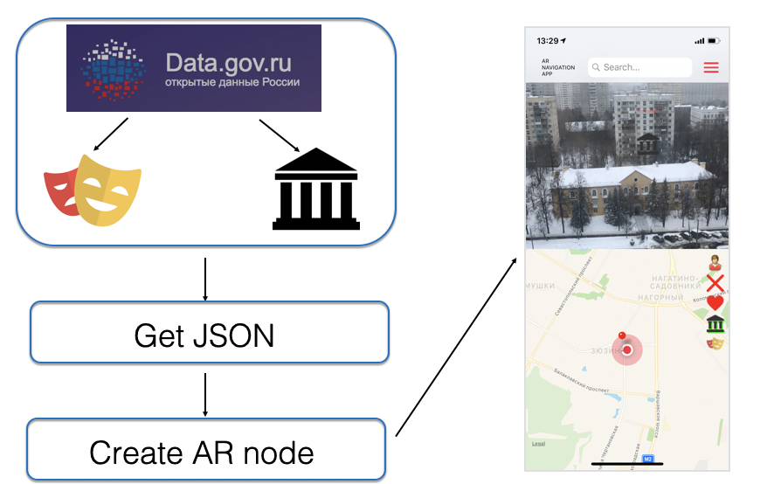

Picture 27. Excursion objects creation

* 1. Widget algorithm

Widget in iOS is an extension that displays useful information and provides app-specific functionality. In case of the current application the main functions are moved to the widget. This step aims to help the user easier interact with the navigation.

In order to let the widget access the functions of the application it is necessary to provide paths for each of the functions as well as specify the logic for each endpoint. When the application starts running it firstly access the application function inside the AppDelegate class. That is why the above mentioned steps was done there (sch. 11).

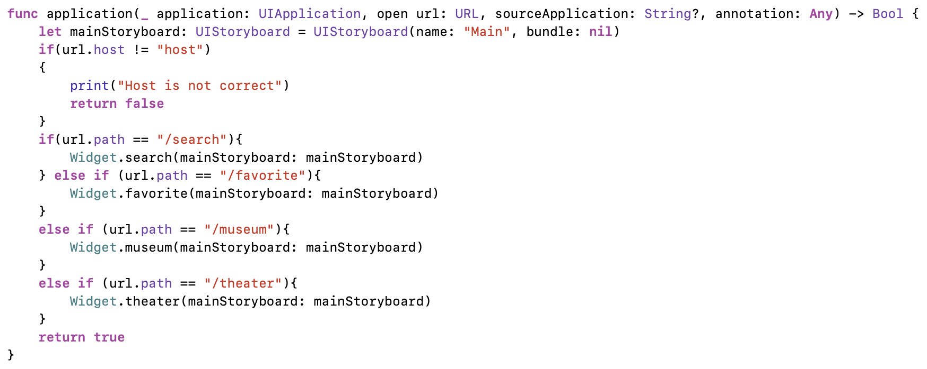

Schema 11. Widget endpoints

Depends on the url path the next steps are chosen. For example, for opening the search page using the widget, the search method is called. It loads the necessary view controller (sch. 12).

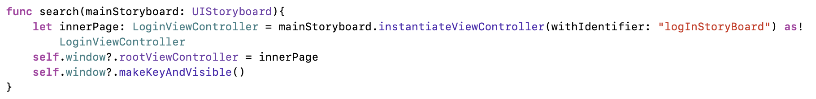

Schema 12. Search endpoint for widget

Conclusion

The chapter described the developed information model, steps, objects, widget and navigation algorithms.

1. Architecture and design

The chapter describes the architecture and the design of the application.

* 1. Architecture description

The application projects contains several modules (pic. 28):

* Storyboard - here the UI (view) is created;
* Service – navigation, location, database, object services;
* Extension – extra functions to existing classes;
* Model – data structure for used model classes;
* Controllers – controllers which get inputs and convert them to commands for the models or views (storyboards);
* Widget – widget logic;
* Products – application and widget build;
* Pods – all project dependencies (libraries, API’s).

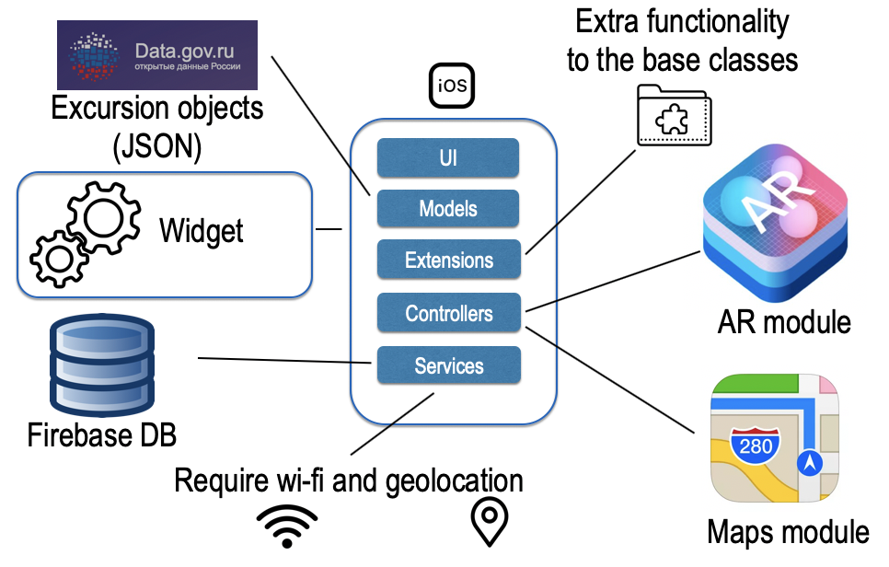

Picture 28. Application modules

As can be seen from the project structure, the main pattern of the development is MVCS – Model-View-Controller-Service (pic. 29). The main idea of MVCS is to have a service layer between the controller and the model, to encapsulate all the logic that could be in the controller. The controllers are in the project only to control the execution of services. Also, it is possible to call a service in numerous controllers without copying code [[25]].

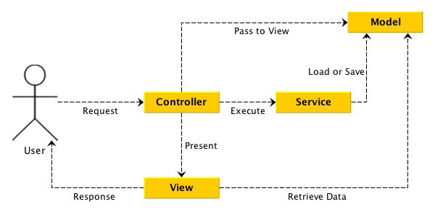

Picture 29. Model-View-Controller-Service pattern

In picture 30 the links between the map navigation interface, AR interface and backstage are cleared. The backstage passes data to both interfaces throughout its life cycle and the two interfaces redirect to each other [[26]].

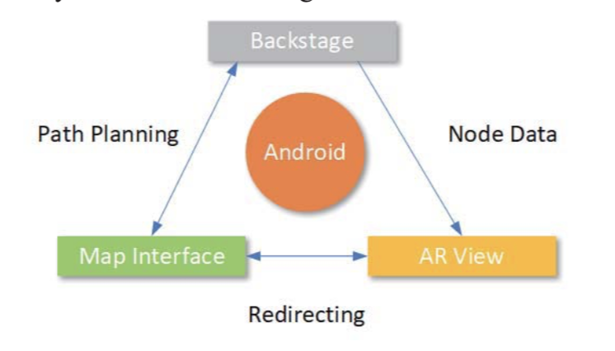

Picture 30. Application parts links

* 1. Design and interface
     1. Application

The application consists of several screens. Each of them are presented below (pic. 31-38).

|  |  |  |
| --- | --- | --- |
|  |  | Изображение выглядит как снимок экрана    Описание создано автоматически |
| Picture 31. Sign in page | Picture 32. Sign up page | Picture 33. Settings page |
|  | Изображение выглядит как текст, карта    Описание создано автоматически |  |
| Picture 34. Favorites page | Picture 35. Example of theaters mode on the navigation page | Picture 36. Example of finish node on the navigation page |
|  | Изображение выглядит как снимок экрана, текст    Описание создано автоматически |  |
| Picture 37. Example of label for a change direction node on the navigation page | Picture 38. Info page |  |

* + 1. Widget

The widget is also a part of the application. However, it exists outside of it. On the widgets page it is possible to add the created widget to the list. After that the widget will appear as it is presented on the picture 39.

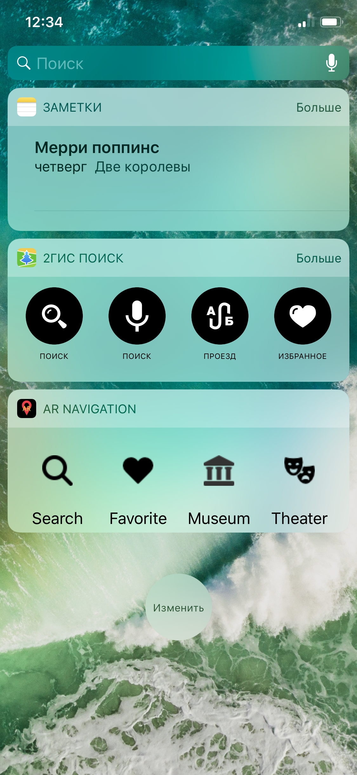

Picture 39. Widget

Conclusion

The chapter presented the architecture and the design of the application.

1. Technology stack and implementation details

The chapter describes the technology stack and the implementation details of the application.

* 1. Development tools

The Xcode was used during the development of the application for writing code. The main programming language is Swift. Design was created using the Figma [22] service according to the iOS guidelines and results of usability testing of the analogues. The main colors are black, red and white. The pictures were created using Adobe Photoshop and Flaticon Basic License. For version control Git [[27]] and GitHub [[28]] was used together with the ZenHub [[29]] plugin.

* 1. Main libraries
     1. ARCL library

The ARCL library [[30]] is the combination of two main technologies used in the current project: AR and CoreLocation. Is combines the high accuracy of AR with the scale of GPS data used during the excursion objects navigation. In order to use the library in the project the pod was installed. After that with the help of imports it is possible to create a SceneLocationView as a subview of the main view. So, the navigation tasks become less complicated. For running the view it is necessary to call the run method, whereas the pause method will stop the execution. For adding the nodes the addChildNode method is called where we pass the actual AR nodes (sch. 13).

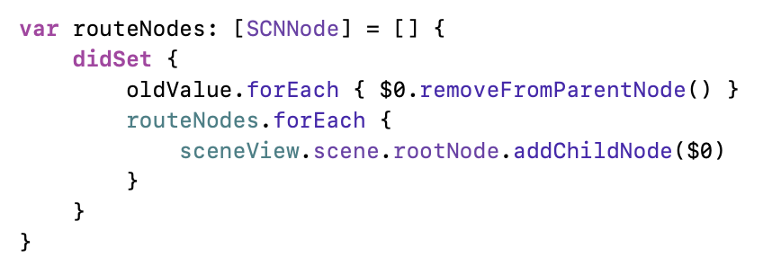

Schema 13. Adding AR nodes to the view

* + 1. SideMenu library

The SideMenu library [[31]] is a helper for the left in-app menu tab coordination. It is used as there is no built in analogue in the iOS components list. So, that is why the SideMenu library was added to the project using the pod installation and the imports. With the help of PageViewController (pic. 40) the page from the menu list is chosen and loaded depends on which button was pressed.

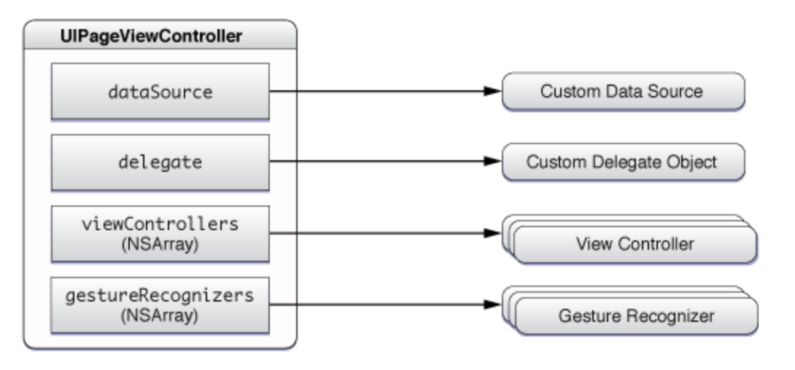

Picture 40. A page view controller and its associated objects

In order to navigate to a page with the identifier “Info” it is necessary to write *self.performSegue(withIdentifier: "Info", sender: self)*.

* + 1. SwiftSpinner library

The SwiftSpinner library [[32]] is used during the process of interaction with data which is linked to the outer sources from the Internet. While the data is being sent or received the spinner is shown to the user in order to demonstrate that the process is going on. Before the request is made it is necessary to write *SwiftSpinner.show("Loading...")* whereas *SwiftSpinner.hide()* at the end.

* + 1. SwiftLocation library

The SwiftLocation library [[33]] helps to connect to the CoreLocation and get and updates on the location without additional request. So, the number of classes and lines of codes was reduced. In order to get the current user’s location it can be written *SwiftLocation.Locator.currentLocation!.coordinate*.

* 1. Main third party services
     1. ARKit

The ARKit is one of the main components of the application. That is why in the requirements list there is a point connected with the ARKit presence on the device. It provides functionality which is responsible to the augmented reality creation.

The ARKit consists of several parts [[34]]:

* ARSession coordinates the camera, motion data and calculations which are used to monitor the world while it is rotating;
* ARFrame contains a video frame and position tracking data which are passed to the ARSession using the currentFrame property. ARKit connects image and the motion tracking data to find the device location;
* ARAnchor is a location – specific position in the real world that is kept regardless of motion or position of the camera;
* ARWorldTrackingConfiguration is a configuration for tracing the orientation, position and for feature points that are gained by the camera of the device (pic. 41);

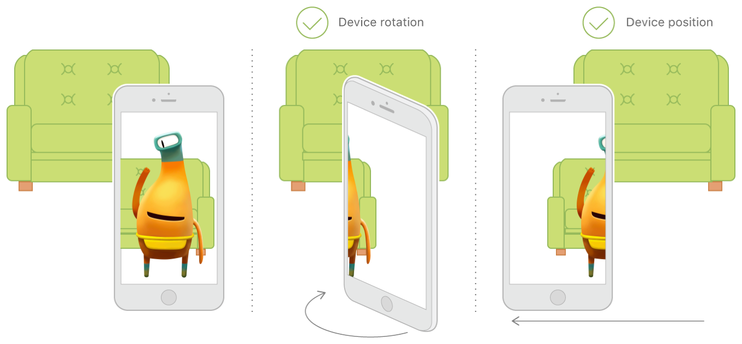

Picture 41. ARWorldTrackingConfiguration usage example

* ARSCNView is the main part of the SceneKit which is already included into the ARKit together with the Metal and SpriteKit. Is is a subclass of SCNView which is the standard SceneKit view for rendering the 3D content. ARKit automatically pairs SceneKit to the real world and places an AR object such that it only requires setting that object’s SceneKit position appropriately which is done using the ARSCNView representations.
  + 1. MapKit

MapKit [[35]] is an iOS built in framework for managing the map tasks. It contains a lot of options which can be used by the developers. The framework is installed through a pod and consists of several parts:

* MKPlacemark is the pin which contains information like city, state, county or street address associated with a concrete location;
* MKRoute is a single route between the start and finish points. The route contains line segments associated with specific map coordinates. From the MKRoute we collect the information: name of the route, its distance, travel time;
* MKRouteStep is one of many parts of a route. The steps algorithm was explained in details in the algorithm section. The steps contain instructions that are easily associated with the MKPlacemarks on the map;
* MKDirections is the element that computes directions and travel-time information based on the route information which is used in the MKRoute.
  + 1. CoreLocation

The CoreLocation [[36]] is the main framework which is used by the ARCL library and all the geolocation functions. It provides services for determining the location, altitude, orientation. The framework uses all built in device’s hardware: Wi-Fi, GPS, Bluetooth, magnetometer, barometer, and cellular hardware in order to collect data. Inside the application all the coordinates are gathered using the CoreLocation classes. However, some extensions were added to them in order to broaden the existing functionality.

* + 1. Firebase

All the collected data is stored in the Google Firebase [[37]] storage, which provides a free, real-time database for developers and a convenient API (pic. 42). This storage format helps users easily recover data if they lose their phones or simply buy a new one, unlike a local storage solution. Already added data is loaded from Firebase directly into the application. For developers, a significant advantage of this service is an error notification system, which automatically generates messages and sends them to the programmer’s email with full information about the fault. This service is also used to authorize and register users in the application (pic. 43).

|  |  |
| --- | --- |
|  |  |
| Picture 42. Realtime database | Picture 43. Users database |

In order to start using the Firebase inside the application it is necessary to write: *FirebaseApp.configure()* in the AppDelegate class. Then to interact with the database *Database.database().reference()* is gained and later using the CRUD operations performing.

* + 1. Crashlytics

Crashlytics [[38]] is a service which can be added to any application using API in order to track the bugs and errors. With the help of Crashlytics it is possible to collect all the necessary information from the device inside which there was a crash even if it is not yours. It can be easily connected with the application as well as the Firebase API. So, all the main components and all the users are under the monitoring of the Crashlytics. The online service shows the stack trace (pic. 44), details about the device as well as provides the logs (pic. 45).

|  |  |
| --- | --- |
|  |  |
| Picture 44. Stack trace example | Picture 45. Logs example |

In order to start using the Crashlytics inside the application together with the pod installation it is necessary to write: *Fabric.with([Crashlytics.self])* in the AppDelegate class. In order to log the important information which may be helpful at the debugging stage the logs are used which are added as follows: *CLSLogv("from: %@", getVaList([data]))*.

* + 1. GitHub

GitHub [28] service is the largest platform for hosting IT projects and their joint development. It was used to monitor progress and control the versions of the code. The service is free for open source projects and has a large number of options to improve the development process. To quickly add updates of the project to the repository, the Git [27] client was used. To control the tasks, an add-in for GitHub - ZenHub [29] was used. The service was used from the first day of work, so there is an opportunity to track how often and diligently the work was done (pic. 46).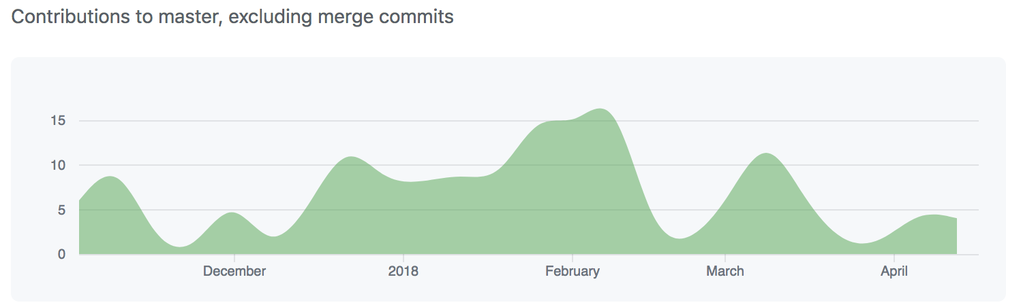

Picture 46. Commits graph

Conclusion

The chapter described the technology stack and the implementation details of the application.

1. Conclusion

Although, it is the 21 century already, most of the citizens prefer to use paper maps or their online analogs in order to find the exact way. However, this case involves a lot of problems: from dependency on the stable internet connection up to the difficulties connected with understanding is it the right place to turn left of right. The existing applications on the market are devoted mainly to the usual maps and do not pay much attention to the improvement of the navigational process, which can positively influence of the user’s experience. So, that is why trying to make the everyday navigation easier seemed a good idea.

The goal of this work was the creation of the mobile IOS application for outdoor AR navigation for pedestrians. The goal of the work was successfully achieved due to competent planning, responsible approach to work and step-by-step implementation of the planned plan of tasks. The created application is used for the route-finding purposes. Using this application users are able to navigate to the destination point from the current location using both usual map and the AR mode.

In the course of the work, an analysis of the mobile application market was carried out and similar programs developed for IOS and Android operating systems were studied. The analysis revealed the main advantages and disadvantages, as well as the minimum necessary functionality, which were taken into account when developing a new application. After the preparatory stage of the work, the final list of application functions was approved and the technical means of implementation and platform were selected. Next, the information model was developed. In parallel with it, the author designed the steps, objects, widget and navigation algorithms, followed by a study of the selected hardware and platform. Next, the modules were defined and the architectures and design of the application were developed. The final stage was the development and manual testing of the application, as well as documentation.

The created project is a feasible contribution in the field of augmented reality and contributes to the spread of modern integrated approaches to navigation. Given the rapid growth of such applications in the market, the work is of great importance, since it solves the mentioned problems that already exist in the applications, and will become a real helper for the pedestrians.

It is worth noting that there are many opportunities for the continuation and development of this work. For example, the support of the Android platform can be added with the help of Google AR. Furthermore, with the rapid growth of the wearable devices popularity the widget may also be ported to the ”clever” bands and watches. The existing outdoor AR navigation algorithm may be improved by adding an indoor version together with the new navigation types. Also, new AR objects groups in other cities might be added as well as the voice and visual helpers. For making the application available to the greater number of people several languages support is planned to be added.

1. References

1. 1. Ipsos knowledge center., Ipsos update [Electronic resource]. URL: https://www.ipsos.com/sites/default/files/2017-06/Ipsos_Update_June_2017.pdf (request date: 05.01.2019);

  
2. 1. Knowband, 10 years of growth of Mobile App Market [Electronic resource]. URL: https://www.knowband.com/blog/mobile-app/growth-of-mobile-app-market/ (request date: 05.01.2019);

  
3. Gartner G, Cartwright W, Peterson MP (2007) Location Based Services and Telecartography. Springer-Verlag, Berlin Heidelberg;
4. 1. Mulloni A., Seichter H., Schmalstieg D. User experiences with augmented reality aided navigation on phones //2011 10th IEEE International Symposium on Mixed and Augmented Reality. – IEEE, 2011. – С. 229-230;

  
5. Chittaro, Luca & Burigat, Stefano. (2005). Augmenting audio messages with visual directions in mobile guides: An evaluation of three approaches. 111. 107-114. 10.1145/1085777.1085795;
6. Hile, Harlan & Vedantham, Ramakrishna & Cuellar, Gregory & Liu, Alan & Gelfand, N & Grzeszczuk, Radek & Borriello, Gaetano. (2008). Landmark-based pedestrian navigation from collections of geotagged photos. MUM'08 - Proceedings of the 7th International Conference on Mobile and Ubiquitous Multimedia. 145-152. 10.1145/1543137.1543167;
7. 1. The Manifest, The Popularity of Google Maps: Trends in Navigation Apps in 2018 [Electronic resource]. URL: https://themanifest.com/app-development/popularity-google-maps-trends-navigation-apps-2018 (request date: 05.01.2019);

  
8. 1. Digi Capital, Augmented/Virtual Reality Report [Electronic resource]. URL: https://www.digi-capital.com/reports/#augmented-virtual-reality (request date: 05.01.2019);

  
9. 1. Tractica, Mobile Augmented Reality [Electronic resource]. URL: https://www.tractica.com/research/mobile-augmented-reality/ (request date: 05.01.2019);

  
10. Liu, Ding-yu (2016). Combined with augmented reality navigation applications in the library. 441-443. 10.1109/ICAMSE.2016.7840320;
11. 1. Milgram, P., Takemunra, H., Utsumi, A. & Kishino, F. Augmented reality: A class of display on the reality-virtuality continuum, 1994;

   
12. 1. Yandex LLC, Yandex Maps [Electronic resource]. URL: https://itunes.apple.com/ru/app/yandex-maps/id313877526?mt=8&ign-mpt=uo%3D4 (request date: 05.01.2019);

   
13. 1. Google LLC, Google Maps [Electronic resource]. URL: https://itunes.apple.com/us/app/google-maps-transit-food/id585027354?mt=8 (request date: 05.01.2019);

   
14. 1. Apple Inc., Apple Maps [Electronic resource]. URL: https://www.apple.com/ios/maps/ (request date: 05.01.2019);

   
15. 1. SPAM Srl, WelcMaps [Electronic resource]. URL: https://itunes.apple.com/ru/app/welc-map/id1099176799 (request date: 05.01.2019);

   
16. 1. Kostas Gaitanis, EyeMaps [Electronic resource]. URL: https://itunes.apple.com/us/app/eyemaps/id1127920895?mt=8 (request date: 05.01.2019);

   
17. 1. Wikitude GmbH, Wikitude [Electronic resource]. URL: https://itunes.apple.com/us/app/wikitude/id329731243?mt=8 (request date: 05.01.2019);

   
18. 1. Chirag Leuva, ARMap [Electronic resource]. URL: https://itunes.apple.com/ru/app/ar-map/id1248166351 (request date: 05.01.2019);

   
19. 1. Mosgortrans, Mosgorpass [Electronic resource]. URL: https://itunes.apple.com/ru/app/мосгорпасс-автобусы-и-метро/id1227002793?mt=8 (request date: 05.01.2019);

   
20. 1. blippar.com, ARCity [Electronic resource]. URL: https://itunes.apple.com/us/app/arcity-ar-navigation/id1282527727?mt=8 (request date: 05.01.2019);

   
21. 1. IDC, Worldwide Quarterly Mobile Phone Tracker [Electronic resource]. URL: https://www.idc.com/tracker/showproductinfo.jsp?prod_id=37 (request date: 05.01.2019);

   
22. 1. Figma, Online UI design tool [Electronic resource]. URL: https://www.figma.com (request date: 05.01.2019);

   
23. 1. Yong-Xu, Qin et al. “Campus Navigation System Based on Mobile Augmented Reality” 2013 6th International Conference on Intelligent Networks and Intelligent Systems (2013): 139-142;

   
24. 1. Movable Type, Calculate distance, bearing and more between Latitude/Longitude points [Electronic resource]. URL: https://www.movable-type.co.uk/scripts/latlong.html (request date: 05.01.2019);

   
25. Wu, Lianyao & Yu, Xiaoqing. (2018). Outdoor Navigation with Handheld Augmented Reality. 237-241. 10.1109/ICALIP.2018.8455285;
26. E. Chin, AP. Felt, K. Greenwood and D. Wagner. “Analyzing inter- application communication in Android,” Proceedings of the 9th international conference on Mobile systems, applications, and services, Bethesda, Maryland, USA, 2011, pp.239-252;
27. 1. Git, Git [Electronic resource]. URL: https://git-scm.com/ (request date: 05.01.2019);

   
28. 1. GitHub, Hosting service for version control using Git [Electronic resource]. URL: https://github.com (request date: 05.01.2019);

   
29. 1. ZenHub extension for GitHub [Electronic resource]. URL: https://www.zenhub.com/ (request date: 05.01.2019);

   
30. 1. GitHub, ARCL library site [Electronic resource]. URL: https://github.com/ProjectDent/ARKit-CoreLocation (request date: 05.01.2019);

   
31. 1. GitHub, Side Menu for IOS library site [Electronic resource]. URL: https://github.com/jonkykong/SideMenu (request date: 05.01.2019);

   
32. 1. GitHub, Swift Spinner for IOS library site [Electronic resource]. URL: https://github.com/icanzilb/SwiftSpinner (request date: 05.01.2019);

   
33. 1. GitHub, Swift Location library site [Electronic resource]. URL: https://github.com/malcommac/SwiftLocation (request date: 05.01.2019);

   
34. 1. Medium, ARKit and CoreLocation [Electronic resource]. URL: https://medium.com/journey-of-one-thousand-apps/arkit-and-corelocation-part-one-fc7cb2fa0150 (request date: 05.01.2019);

   
35. 1. Apple Inc., MapKit [Electronic resource]. URL: https://developer.apple.com/documentation/mapkit/mkmapview (request date: 05.01.2019);

   
36. 1. Apple Inc., CoreLocation [Electronic resource]. URL: https://developer.apple.com/documentation/corelocation (request date: 05.01.2019);

   
37. 1. Google LLC, Firebase [Electronic resource]. URL: https://firebase.google.com/ (request date: 05.01.2019);

   
38. 1. Google LLC, Crashlytics [Electronic resource]. URL: https://firebase.google.com/docs/crashlytics (request date: 05.01.2019);
    2. Mata Rivera Miguel, Claramunt Christophe, Juarez Alberto. An experimental virtual museum based on augmented reality and navigation, 497-500, 10.1145/2093973.2094058, 2011;
    3. Narzt Wolfgang, Pomberger Gustav, Ferscha Alois, Kolb Dieter, Maјller Reiner, Wieghardt Jan, Hartner Horst, Lindinger Christopher. Augmented reality navigation systems. Universal Access in the Information Society, 4, 177-187, 10.1007/s10209-005-0017-5, 2006;
    4. Reitmayr Gerhard, Schmalstieg Dieter. Collaborative augmented reality for outdoor navigation and information browsing, Proceedings of the Symposium on Location Based Services and TeleCartography, 2004;
    5. Raskar Ramesh, Low Kok-Lim. Interacting with Spatially Augmented Reality, ACM International Conference on Computer Graphics, Virtual Reality and Visualisation in Africa, 10.1145/513867.513889, 2001;
    6. Alessandro Mulloni , Hartmut Seichter , Dieter Schmalstieg. User experiences with augmented reality aided navigation on phones, Mixed and Augmented Reality (ISMAR), 2011;
    7. Kyle Roche. Pro iOS 5 Augmented Reality, 345, APRESS, 2011;
    8. Randall Shumaker Stephanie Lackey (Eds.). Virtual, Augmented and Mixed Reality. Applications of Virtual and Augmented Reality, 6th International Conference, VAMR 2014 Held as Part of HCI International 2014 Heraklion, Crete, Greece, June 22–27, 2014, Proceedings, Part II;
    9. Swift developer blog, “Pass Information Back to the Previous View Controller” [Electronic resource]. URL: https://swiftdeveloperblog.com/pass-information-back-to-the-previous-view-controller/ (request date: 03.01.2019);
    10. LongList, IOS Popup View Using Separate View Controller [Electronic resource]. URL: http://longlist.org/ios+popup+view+using+separate+view+controller++xcode+8++swift+3 (request date: 05.01.2019);
    11. Ray Wenderlich, Augmented Reality and ARKit Tutorial [Electronic resource]. URL: https://www.raywenderlich.com/378-augmented-reality-and-arkit-tutorial (request date: 09.02.2019);
    12. Collective Idea, ARKit Wall and Plane Detection for iOS 11.3[Electronic resource]. URL: https://collectiveidea.com/blog/archives/2018/04/30/part-1-arkit-wall-and-plane-detection-for-ios-11.3 (request date: 05.01.2019);
    13. YouTube, GPS search [Electronic resource]. URL: https://www.youtube.com/watch?v=8-TDf_7j59Y (request date: 05.01.2019);
    14. GitHub, Swift Auto Diagram for IOS tool site [Electronic resource]. URL: https://github.com/yoshimkd/swift-auto-diagram (request date: 17.01.2019);
    15. Rochester Institute of Technology, Introduction to Augmented Reality [Electronic resource]. URL: http://www.se.rit.edu/~jrv/research/ar/introduction.html (request date: 23.01.2019);
    16. Academia.edu, Scientific platform [Electronic resource]. URL: https://www.academia.edu/ (request date: 12.01.2019);
    17. YouTube, Walkthrough screens creation [Electronic resource]. URL: https://www.youtube.com/watch?time_continue=73&v=1F_HVMHocdA (request date: 21.11.2018);
    18. SwiftBook, Marshrutisation with MapKit and Core Location [Electronic resource]. URL: https://swiftbook.ru/post/tutorials/marshrutizaciya-s-mapkit-i-core-location/ (request date: 07.12.2018);
    19. HackerNoon, Building a location app with ARKit, CoreLocation and Pusher [Electronic resource]. URL: https://hackernoon.com/building-a-location-app-with-arkit-corelocation-and-pusher-bee44fdec44f (request date: 05.02.2019);
    20. Russia Open Data [Electronic resource]. URL: https://data.gov.ru/ (request date: 25.01.2019).

   